**Assignment No 01**



**Fall 2022**

**CSE-302L Systems Programming**

**Submitted by**:

Maaz Habib

**Registration number:**

20PWCSE1952

**Class Section:**

C

“On my honor, as a student of University of Engineering and Technology I have neither given nor received unauthorized assistance on this academic work”

**Submitted to:**

Engr. Madiha Sher

Thursday December 8, 2022

Department of Computer Systems Engineering

University of Engineering and Technology, Peshawar

**Question 1:**

**Code:**

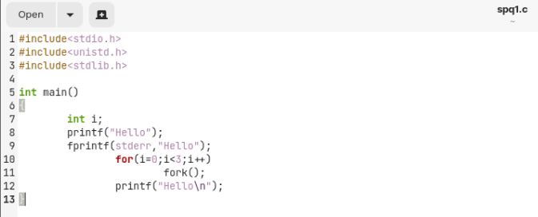

**Output:**

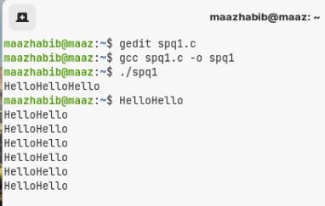

**Question 2:**

Label all the section of process image in the following figure and show that how it locks after the execution of the following piece of code:

|  |  |
| --- | --- |
| CLAs, c d =20 | CLAs |
| Static uninit: a  Static init : b = 10 | Heap |
| t | stack |
| Main stack  e – 30  sum stack,(x+y) | Stack |
| code | Text |

**Question 3:**

What will be the output of the following code?

**Code:**

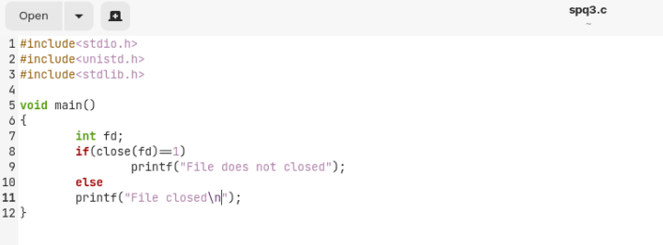

**Output:**

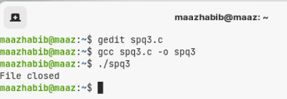

**Question 4:**

**Process fan:**

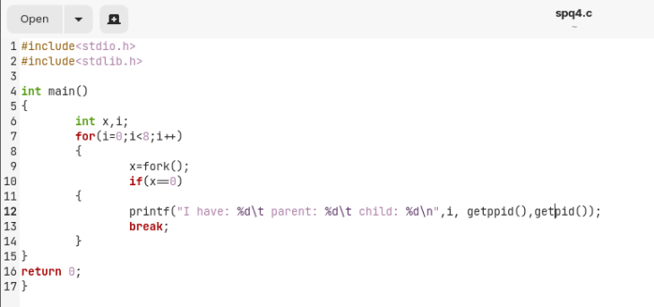

**Output:**

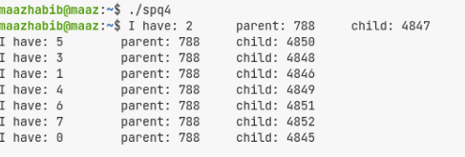

**Question 5:**

**Code:**

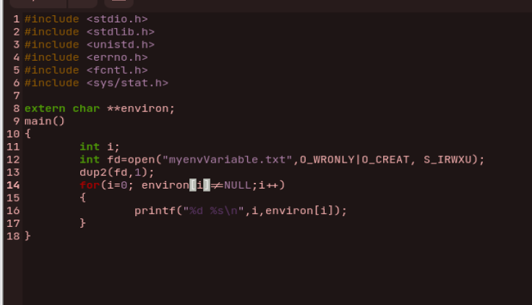

**Output:**

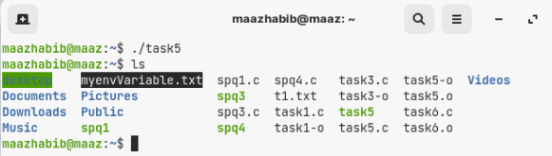

**Question 6:**

**Code:**

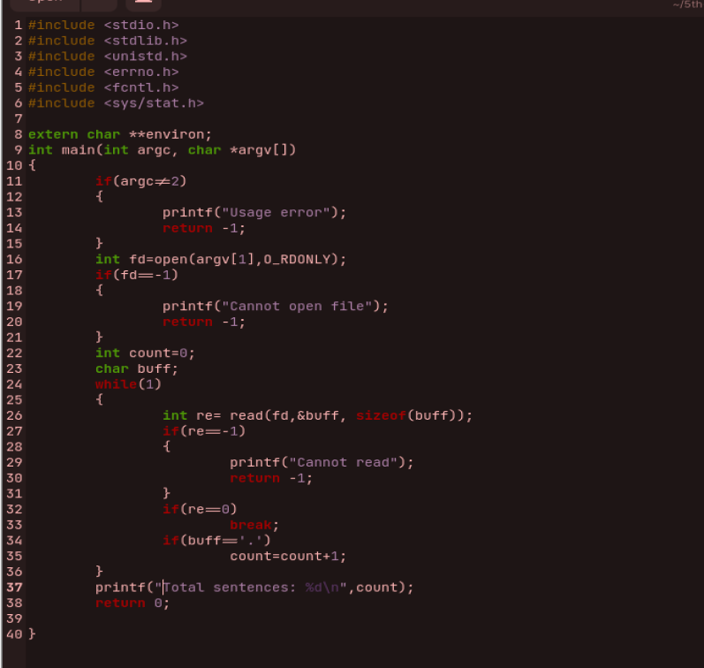

**Output:**

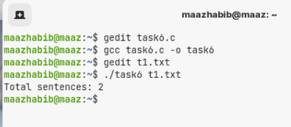

**Question 7:**

**Code:**

**Min:**

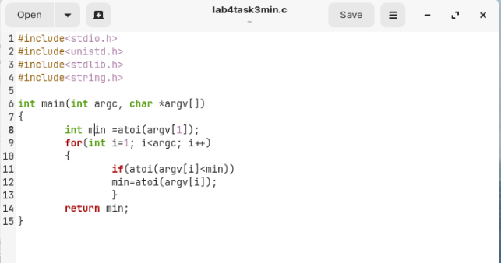

**Max:**

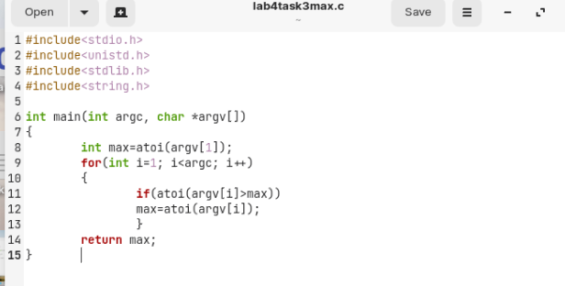

**Minmax:**

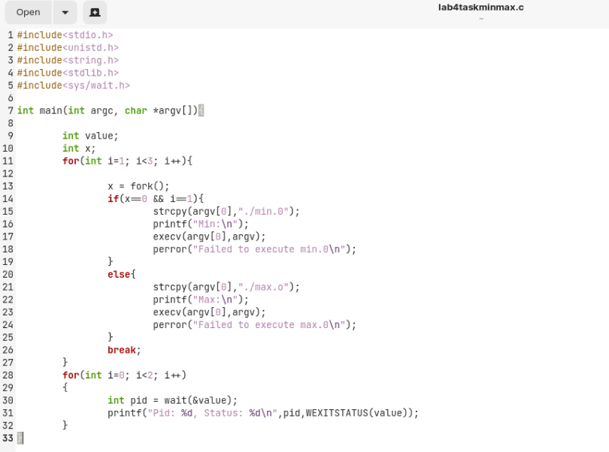

**Output:**

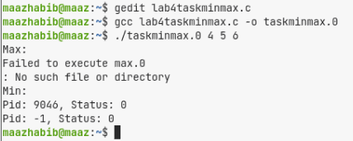

**Question 8:**

**Fd tables:**

Parent:

|  |
| --- |
| STDIN_FILENO |
| STDOUT-FILENO |
| STDERR_FILENO |
| fd1 |
| Fd2 |
|  |

Child:

|  |
| --- |
| fd1 |
| Fd2 |
| STDERR_FILENO |
| fd1 |
| Fd2 |
|  |

System File Table:

|  |
| --- |
| my.dat  Offset=0 |
| my2.dat  Offset=0 |
| my2.dat  Offset-=0 |

I node Table:

|  |
| --- |
| my.dat  # of link:1 |
| my.dat  # of link:2 |